Friends --

Tomorrow morning, residents from Horry County are holding protests outside of the offices of the Conservation League and South Carolina Environmental Law Project in Georgetown.

These people are smearing the conservation community, peddling misinformation, and resorting to other nefarious tactics in the name of paving and widening International Drive in Horry County.

Here is the truth.

In 2010 the South Carolina Department of Natural Resources (SCDNR) agreed to a compromise with Horry County officials to allow the paving of International Drive through Lewis Ocean Bay Heritage Preserve as long as three underground bear passageways were included in its construction.

Now, Horry County officials have gone back on their word. They have broken their promise and plan to build the road without the underground bear passageways.

We need your help. Sign our petition today calling on Horry County officials to incorporate the bear passageways under International Drive.

Background

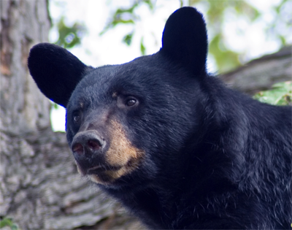

The Lewis Ocean Bay Heritage Preserve in Horry County is home to the largest population of coastal black bears in the state. They are cute, big, and harmless — unless and they are in the path of your vehicle.

Lewis Ocean Bay Heritage Preserve is one of the largest, most pristine bay complexes in the world – comprised of more than 20 intact Carolina Bays. Carolina Bays are massive geological impressions, sometimes thousands of acres in size, scattered throughout the Southeastern United States. They are magnificent wetlands, and their unique habitat is home to many rare plants and animals, including Venus flytraps, pitcher plants, sugar white sand rims, and, of course, the black bear.

A road without crossings is a danger to these sweet bears, but it also poses a threat to people driving on nearby roads and certainly on International Drive. If you consider the damage that a 100 pound white tailed deer can do to your car (and the passengers in it), imagine what damage a collision with a 350 pound black bear causes!

The public trusts SCDNR to steward the Lewis Ocean Bay Heritage Preserve in a manner that conserves wildlife and habitat. SCDNR's original conveyance of Heritage Trust property to Horry County in 2010 for the construction of this road included the condition that underground bear passageways be included. Three years later, Horry County asked SCDNR to eliminate the underground bear passageways in exchange for a handsome sum of money that wasn't included in the first contract.

Help us speak out and demand that Horry County honor the original agreement and include underground bear passageways in the widening and paving of International Drive.

Sign here: https://coastalconservationleague.org/bears

Thank you for standing up for our coast and all of the creatures that make it such a special place to live.

Nancy Cave
North Coast Office Director
Coastal Conservation League

